**Project Title:**

**Bank Customer Churn Analysis Using Power BI and Python:**

***Section A: Power BI – Business Intelligence & Dashboards :***

1. **What is the overall churn rate, and how does it trend over time (if applicable)?**

1. **How does churn vary by geography (France, Germany, Spain)?**

**3) What are the differences in churn rates between male and female customers?**

1. **What is the churn rate distribution across different age groups?**

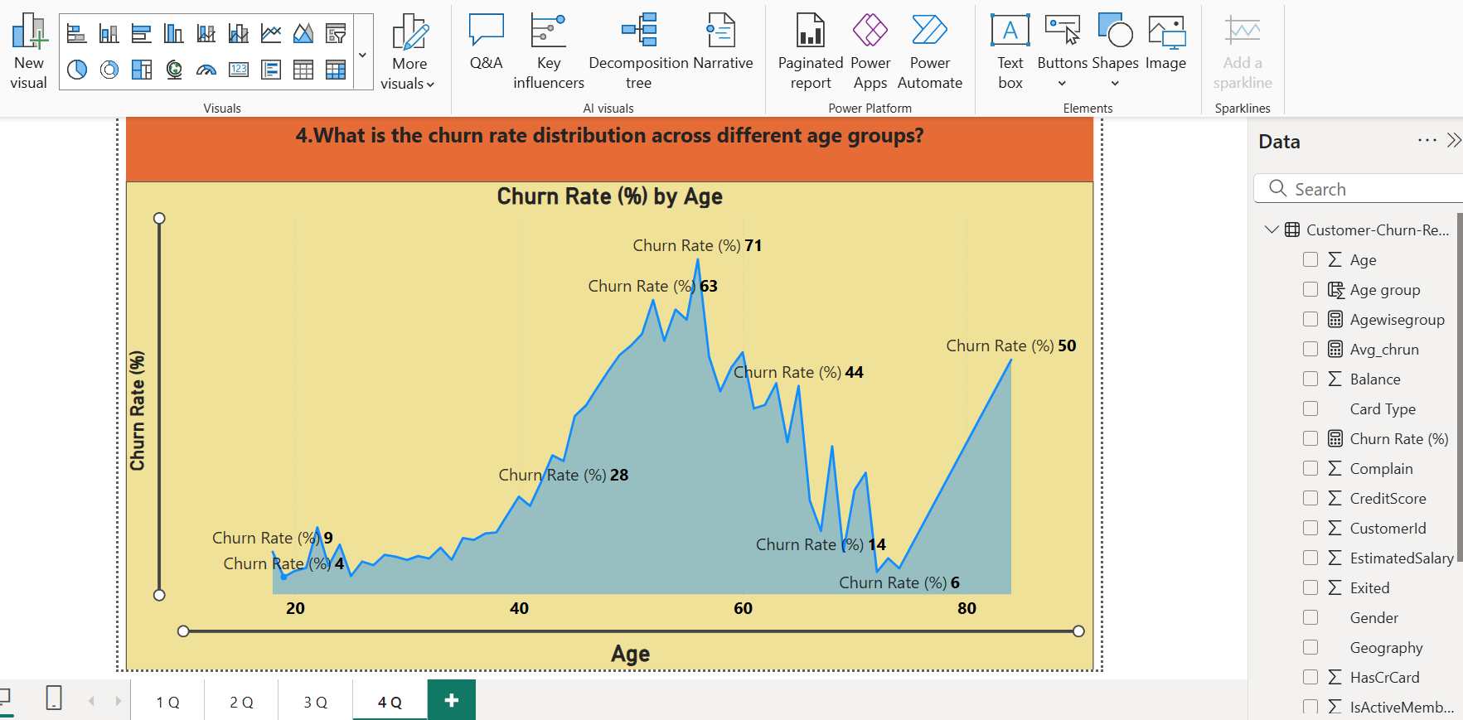

**5. How does churn behavior change with tenure?**

**6. What percentage of high-balance customers (e.g., >$100K) have churned?**

**7. How do churn rates compare across different NumOfProducts?**

**8. Are inactive members (IsActiveMember = 0) more likely to churn?**

**9. Can we build a KPI dashboard to track churn metrics like average salary, balance, and active users?**

**10. What does a customer persona dashboard (churned vs. retained) look like?**

# **Section B: Python – Statistical Analysis & Visuals**

1. **Check the percentage of missing data and handle accordingly.**

**12.How many rows and columns are there in the dataset?**

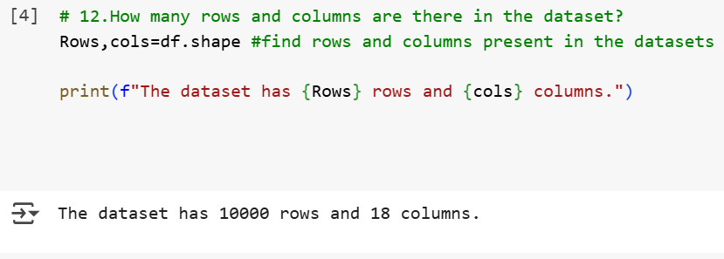

**13. What is the distribution of churned vs. non-churned customers?**

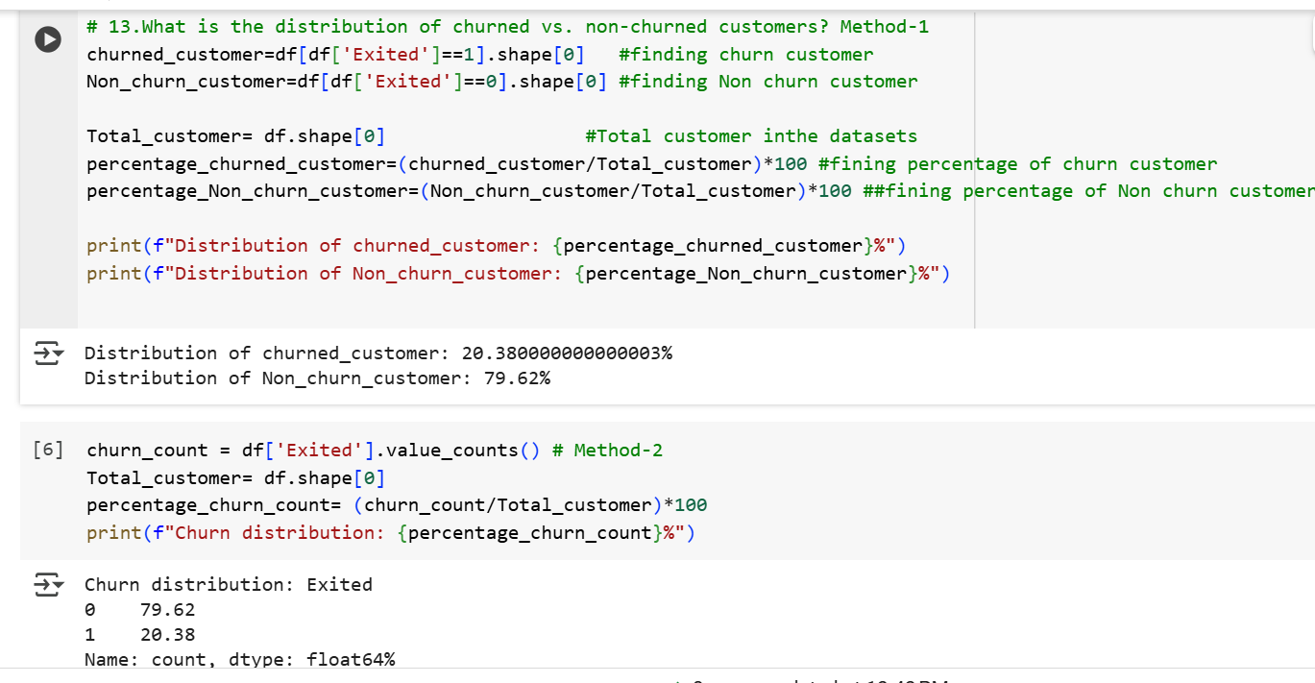

**14.What is the distribution of EstimatedSalary of churned and retained Customers?**

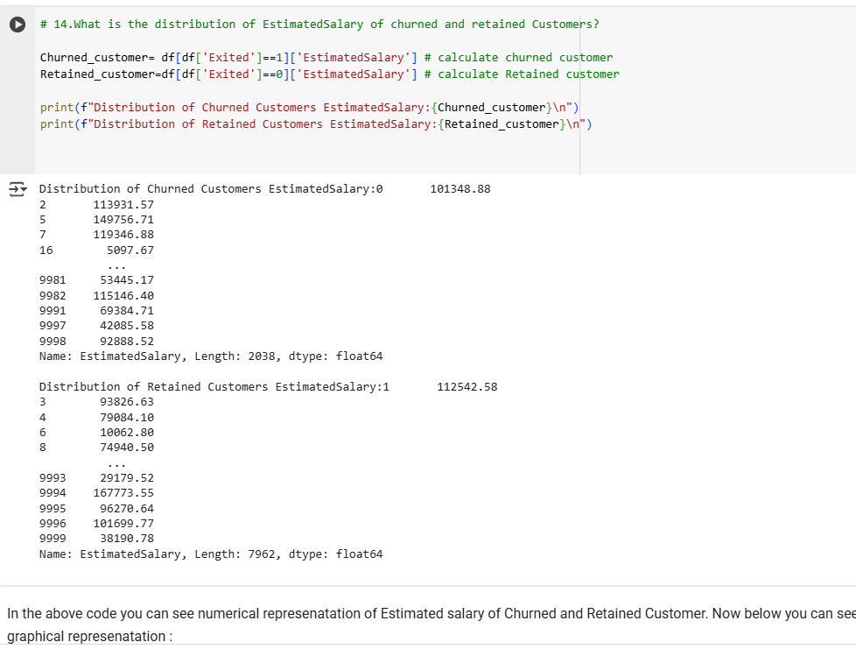

**15. How do churn rates vary by Gender, Geography, and IsActiveMember?**

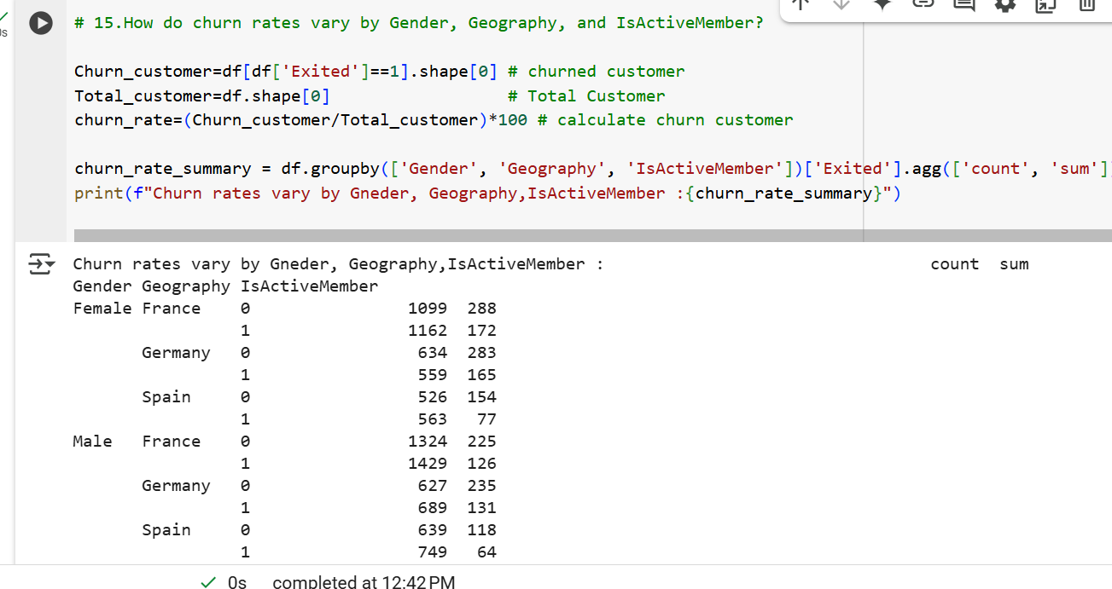

**16.What is the average CreditScore, Balance, and EstimatedSalary of churned vs. retained customers?**

**# 18.Is there any correlation among numeric features like CreditScore, Balance, and EstimatedSalary?**

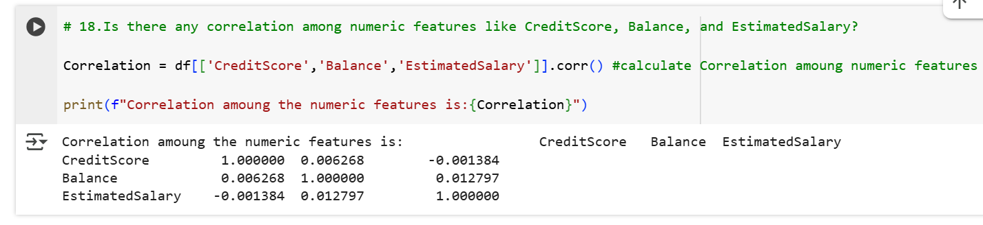

1. **. What does a heatmap reveal about feature interactions with churn?**

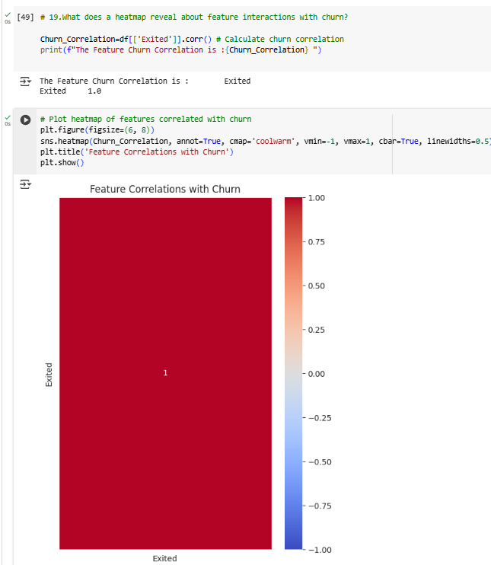

**22. Are customers with only one product (NumOfProducts = 1) more likely to churn than those with multiple?**

**The End…Thank You!**